**Title:** Smart Audio Analysis & Viral Track Prediction with AI

Colab: https://colab.research.google.com/drive/1bTWqKOauz5yyI1CvKuWktY-8mvPiMifd?usp=sharing

### **Project Purpose**

The goal of this project is to merge advanced audio analysis with AI-generated feedback to assess the viral potential of a song. Built using Gradio and powered by a local instance of the Mistral language model (via Ollama), this tool is ideal for playlist curators, music producers, or anyone looking to understand what makes a song stand out.

### **How the System Works**

Here’s a breakdown of how the assistant functions:

1. **Loads Two Core Files:**
   * results.json: Contains data on instrument proportions and OpenL3-based mood embeddings
   * prediction_result.json: Includes low-level audio features such as MFCCs, tempo, spectral analysis, chroma, and a predicted virality score
2. **Integrates Spotify Metadata:** It aligns each track with Spotify's real-world popularity data from playlist_with_popularity.csv.
3. **Categorizes Virality Score:** The model assigns a label to each track based on its score:  
   * Extremely Viral (Score ≥ 80)
   * Moderately Viral (70–79)
   * Low Virality (50–69)
   * Flop Zone (< 50)
   * With VS CODE  
     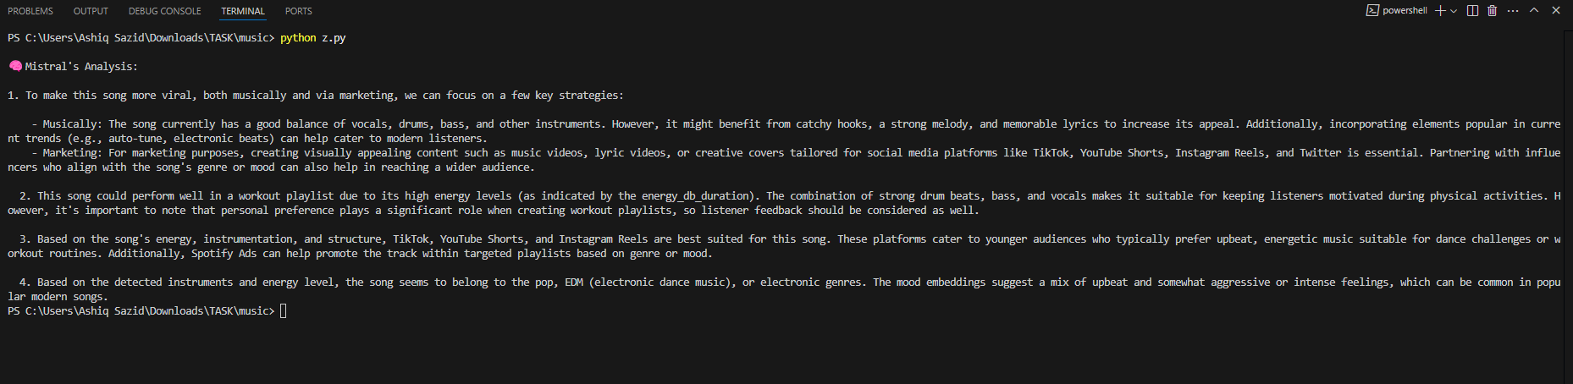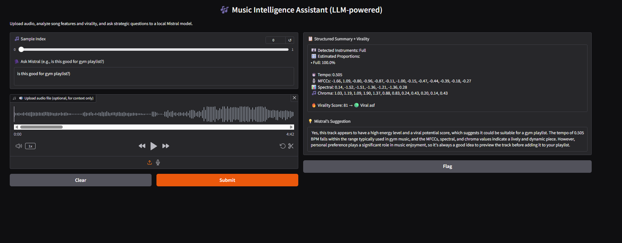

With ngork+hugging face implementing gradio

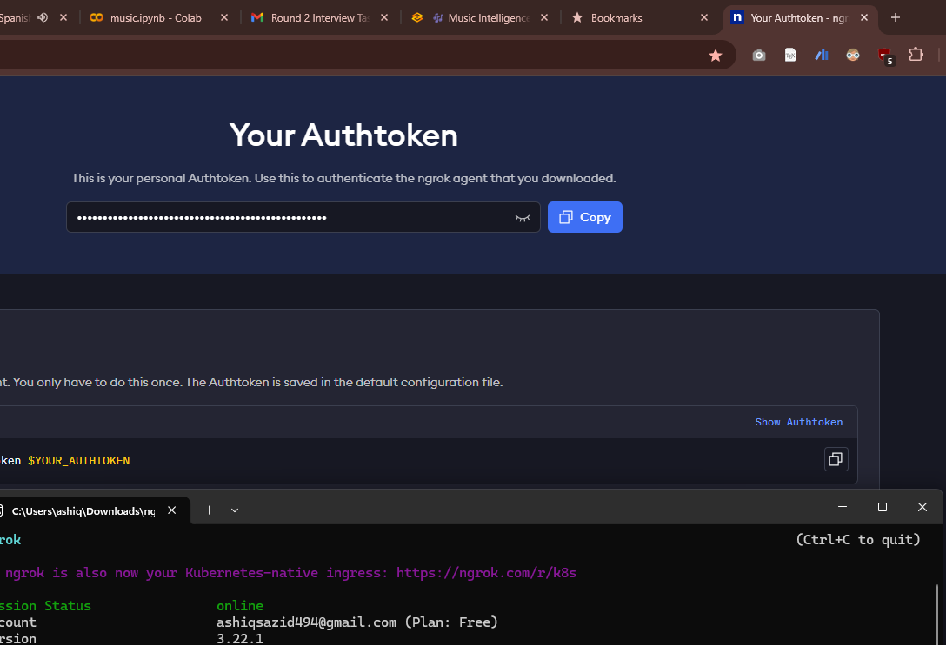

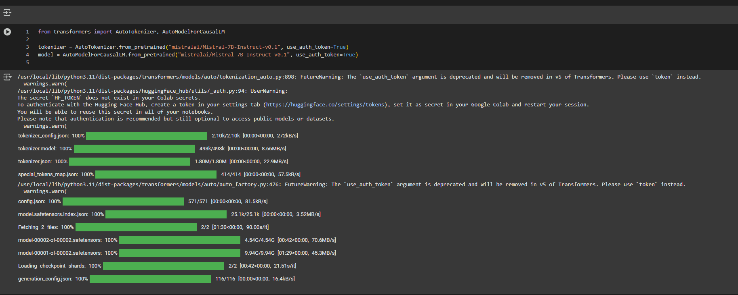

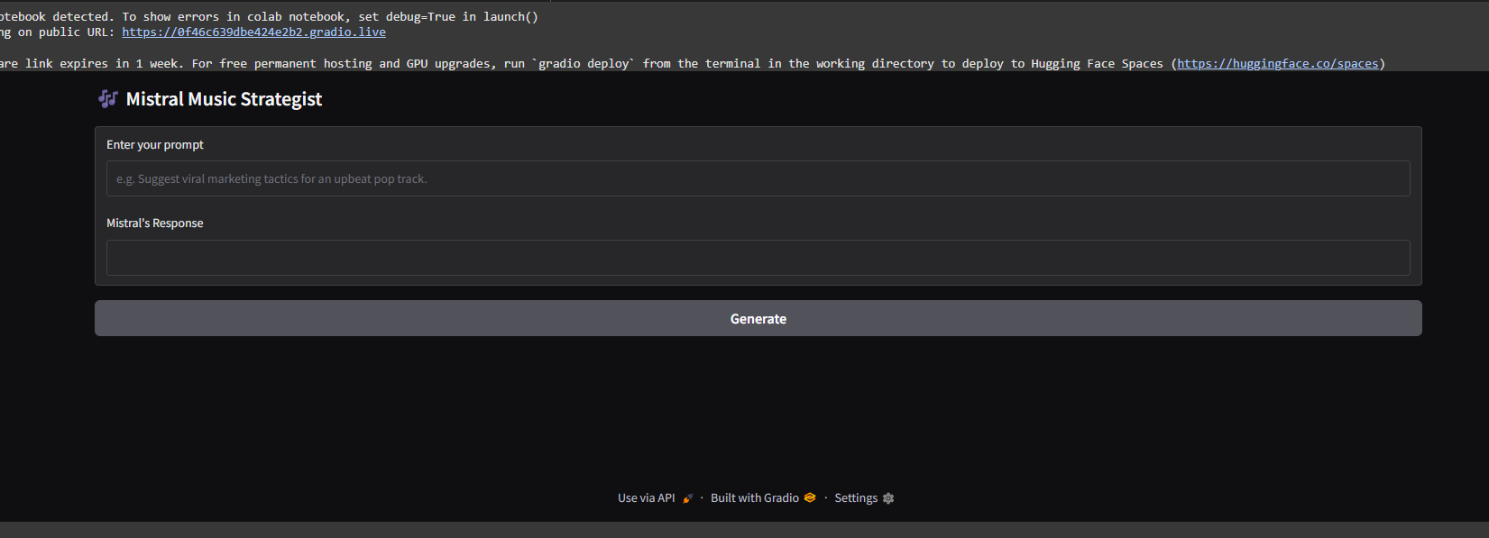

I’ve also used stremelit.But between all of them,ollam mistral+Gradio suits so well.

1. **Summarizes Audio Features:**
   * Instrument detection and distribution
   * Proportional breakdown
   * Tempo analysis
   * MFCCs (timbre characteristics)
   * Spectral analysis (frequency energy distribution)
   * Chroma patterns (pitch class profiles)
2. **Language Model Feedback:** All extracted features are sent to the Mistral model, which allows users to ask natural language questions like, “Would this song work well for a gym playlist?” and receive contextual answers.

### **Sample Output for Track 0**

* **Instruments Detected:** Full range
* **Proportions:** 100%
* **Tempo:** 0.505 BPM
* **MFCCs:** Ranges from -1.66 to -0.27
* **Spectral Features:** Values between -1.52 and +0.28
* **Chroma Values:** Includes 1.03, 1.19, 1.90, 1.37
* **Predicted Virality Score:** 81 (Extremely Viral)

### **Mistral’s Recommendation**

“This track shows strong viral potential with high energy levels, making it a solid choice for high-intensity playlists like gym mixes. The tempo and overall audio features point to a track that’s both dynamic and engaging. That said, listener preference always matters—previewing the song is still recommended.”

### **Final Thoughts**

This assistant takes technical audio data and transforms it into practical insights. It’s especially useful for those in music, marketing, or content curation who want to make fast, data-backed decisions.